Name ____________________________________________ Date _____________ Period _______
The Lorax Video Questions
- What natural resource did the Once-ler find?
- What happened to them?
- The Once-ler used natural resources to start his business… what was he selling?
- Why was the Once-ler so determined to make this product?
- How many people and animals were affected by the Once-ler’s actions?
- How were they affected? (List at least 3 ways)
- What did the area look like when the last Tuffula was cut down?
- How did the Once-ler feel when he no longer had the resource?
- What could the Once-ler have done differently to protect the Truffulas?
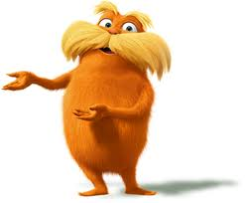
- What natural resource that is vital for survival was being sold by Mr. O’Hare? What natural resource that is vital for survival is being sold now?

