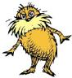
The Lorax Assignment
While watching the movie you need to be answering the questions. You will be writing an in class 5 paragraph essay on the prompt below, answering ALL parts of the prompt. Both the essay and the notes will be turned in at the end of the hour.
A) Discuss how The Lorax parallels real life issues that occur in the environment.
1. What species became extinct in the story? Why?
2. What else was affected by the loss of the trees? Why and How?
3. What is the natural resource?
4. What are the wastes by products?
5. What could they have done to protect the species in the story?

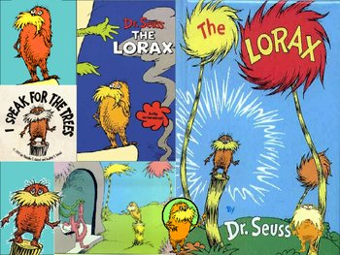

“Unless someone like you cares a whole awful lot, nothing is going to get better. It's not,” proclaims the Lorax in this cautionary tale of greed and environmental destruction.

