Name _________________________________________ Period _________ Date ______________
Chemistry Recovery Worksheet
You have received less than an 80% on your Chemistry Quiz. You need additional practice on these concepts. If you need help, please come in for tutoring!!!!
Have you Period Table of Elements out to use while filling out this worksheet.
8  O  Oxygen  15.999 |  | Atomic Number  Symbol  Element Name  Atomic Mass | 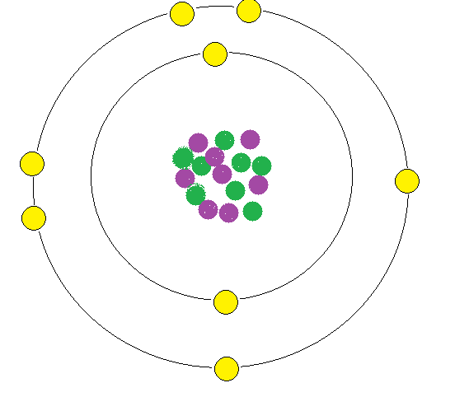

- What is the Atomic Number of Oxygen? _________ The number of protons in the nucleus of the atom is equal to the Atomic Number. How many protons does Oxygen have? ________ (these two numbers should be the same)
- The Atomic Mass is the average mass of all Oxygen atoms. What is the Atomic Mass of Oxygen? _________________ The Mass Number is the Atomic Mass rounded to the nearest whole number ( _.0 - _.4 round down, _.5 - _.9 round up). What is the Mass Number of Oxygen? _______
- Within the nucleus of the atom, there are protons and neutrons. These make up the mass or Mass Number of the atom.
Protons + Neutrons = Mass Number (is the same as) Mass Number – Protons = Neutrons
How many neutrons does oxygen have? __________
- In an atom (that is not an ion), the number of electrons is equal to the number of protons. How many electrons does Oxygen have? __________ (this should be the same number as the answers in question 1)
More Practice:
Element | Element  Symbol | Atomic Number | Atomic Mass | Mass Number | Protons | Neutrons | Electrons
5. Nitrogen |  |  |  | 14
6. | F |  |  |  | 9
7. |  | 20 |  |  |  | 20
8. |  |  | 39.948 |  |  |  | 18

Lewis Dot Diagrams are designed to show the number of electrons in the outer orbit of the atom. The columns should have been labeled on your periodic table. Whichever column the element is in, is the number of dots that should surround the Element Symbol.

Example for Oxygen: O

- N
- F
- He
- Mg

Covalent Bonding occurs when 2 or more atoms share electrons within a molecule. Atoms are “happy” when they have 8 electrons in their outer shell. Use Lewis Dot Diagrams and single bonds (two electrons), double bonds (four electrons), or triple bonds (six electrons) to make all of the atoms happy. Remember, Hydrogen is an exception and only needs 2 electrons to be happy.

Example of H₂O: H O H

- CO₂
- NH₃
- F₂
- N₂

Ions are charged particles. In ions, there is an unequal number of protons and electrons. Since you cannot change the number of protons in an atom, it must be the electrons that were gained or lost. If you see a positively charged ion, you subtract electrons. If you see a negatively charged ion, you add electrons.
Element | Atomic Number | Protons | Electrons
Ex: Cl- | 17 | 17 | 18
13. Na⁺
14. H⁻
15. Al⁺³

