Name:_____________________________ Date:_______________________ Period: ________________

Cellular Respiration

Objective:
To examine cellular respiration by observing aerobic and anaerobic respiration of yeast in an enclosed fluid environment.
Background:
Mitochondria are the cells’ power sources. They are the second largest organelles. Mitochondria are generally rod-shaped, with a double-layered outer membrane with inner folds called cristae. Energy-producing chemical reactions take place on the cristae. Chemical energy is stored in the chemical bonds of glucose. This energy is transferred into ATP molecules through the process of aerobic respiration. Aerobic respiration is broken down into three processes. The first process is glycolysis, which occurs in the cytoplasm. The second process is the Krebs cycle, also called the Citric Acid cycle, occurs in the mitochondrial matrix. The last process, called the Electron Transport Chain, occurs in the inner mitochondrial membrane.
Yeast is a facultative anaerobe. If no oxygen is present in their environment, they will respire anaerobically. ATP will be made through substrate-level phosphorylation during glycolysis. This requires no oxygen. To regenerate the NAD⁺ needed for glycolysis, the yeast will undergo alcoholic fermentation. At this point, CO₂ id produced.

Materials:
50 ml Erlenmeyer Flask
2.5 ml of yeast
40 ml of apple juice
Balloon
10 ml graduated cylinder
50 ml graduated cylinder
Ruler and String

Procedure:

- Using a pencil, write your name and period on the flask.
- Place 2.5 ml of yeast in the flask.
- Add 40 ml of apple juice to the flask.
- Gently swirl the flask to mix the yeast and apple juice.
- Tightly stretch the balloon over the opening of the flask.
- Write your initial observations and prediction of what will occur after 24 hrs.
- After 24 hrs, measure the circumference of the balloon and note new observations.
- After 48 hrs, measure the circumference of the balloon and note new observations.
- After 72 hrs, measure the circumference of the balloon and note new observations.
- After 96 hrs, measure the circumference of the balloon and note new observations.
- Clean up lab and answer questions.

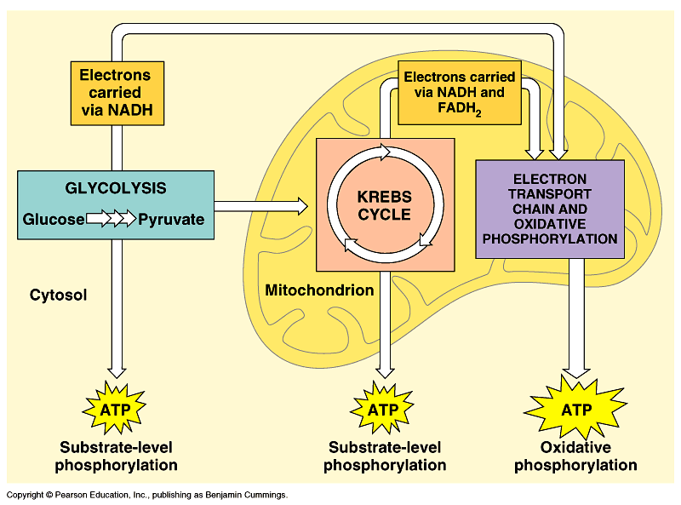

Questions:
- What is the difference between aerobic and anaerobic respiration?

- Describe the basic physical structures of the mitochondria.

- What is the significance of an increase in the number of cristae in a mitochondria?

- What is ATP?

- Trace the steps leading from the products of glycolysis to the Kreb’s cycle and the electron transport chain.

- Where does each of these processes occur in the cell?

- How many ATP molecules of ATP are produced from one molecule of glucose?

- How many of these ATP molecules were produced from the process of glycolysis?

- How many of these ATP molecules were produced from the Kreb’s cycle?

- What was the TOTAL ATP production in the Electron Transport Chain?

- What is Pyruvate?

- How many pyruvates are produced from one molecule of glucose?

- What is the balanced chemical equation for Cellular Respiration?

Data Analysis:
Draw a line graph of the balloon circumference. Place the number of hours on the X-axis and the circumference on the Y-axis. Do not forget to put units of measurement.

